

**The Retrofittable Standing Desk Converter**

Team 09

**Final Report**

MEAM 4450/4460, MEAM Senior Design

September 2022 — April 2023

Submission Date: May 4, 2023

| **Griffin Addison**  Design & Prototyping  griffinnosidda@gmail.com | | **Darrion Chen**  Design & Manufacturing  darrion.chen@gmail.com | | **Jonathan Lee**  Electrical & Software  jcl4.jonathan@gmail.com | |
| --- | --- | --- | --- | --- | --- |
| **Prof. Graham Wabiszewski**  Senior Design Professor  grahamw@seas.upenn.edu | | | **Prof. Bruce Kothmann**  Faculty Advisor  kothmann@seas.upenn.edu | | |
| **Joah Kim**  Team Advisor  joahkim@seas.upenn.edu | | | **Philip Sieg**  Team Advisor  philsieg@seas.upenn.edu | | |

# 

**Abstract**

Adjustable standing desks offer physical and mental health benefits[1], and the market is expected to see a 50% growth in the next 5 years.[2] However, there currently exists a barrier-to-entry for potential standing desk customers: the only two available options are to buy a full new standing desk or a tabletop standing desk converter. The former option generally costs upwards of $350[3] and is not portable, while the latter option is clunky, uses space inefficiently, and is often manually operated. There is currently no suitable product on the market for customers looking for a portable and electrically operated solution, nor for customers who want to easily retrofit a desk they already own.

Our solution, ELEVATE, is portable, inconspicuous, retrofittable, compatible with the majority of existing desks, and provides identical performance to typical standing desks, all while costing less than $250. ELEVATE achieves these characteristics by using four independent motorized risers positioned under the desk legs and a single desk-mounted button panel for control.

Customers looking to retrofit their desk with ELEVATE will be happy to find that it meets all the performance characteristics the market has come to expect of standing desks. It has >300 [lb] load capacity, 1.5 [ft] of height adjustability, a 0.5 [in/sec] lifting speed, and a seamless and reliable user experience. Additionally, ELEVATE customers are not limited to specific desk options, as ELEVATE was designed to maximize desk compatibility. Whether it is an architect’s drafting table or a heavy gothic desk, it can be ELEVATE’d!

Team ELEVATE is composed of Griffin Addison, Darrion Chen, and Jonathan Lee and is advised by Professor Bruce Kothmann.

**Table of Contents**

I. Introduction 2

I.I. Social Impacts of the Solution 3

II. Characteristics 4

II.I. Design Impact of Standards 5

III. Design, Engineering, and Realization 6

Leg Holder Design 7

Initial Plastic Prototype 9

Full Metal Prototype 10

Electrical System 10

IV. Final System Form 13

Leg Mounting 15

Design for Manufacturing 15

Floating Lead Screw Coupler 16

Electrical Architecture 16

V. System Performance 17

VI. Conclusions and Future Work 20

VII. Statement of Roles 21

VIII. Acknowledgements 22

References 23

Appendix 25

# 

# I. Introduction

Standing desks are desks that can be used to work comfortably while sitting or standing. Their usage is correlated with improved posture, reduced neck and shoulder pain, vitality improvement, reduced stress, and increased productivity.[1], [4] Due to the physical and mental health benefits, standing desks are becoming an increasingly popular choice in many corporate and work-from-home office setups.[2]

Unfortunately, the majority of standing desk solutions on the market are considerably more expensive than the average non-standing desk, largely due to the added mechanical and electrical complexity. The cheapest standing desks available on Amazon start at $150, while standing desks from name brands such as Fully and Uplift start at $500. Standing desks also increase waste as they are designed to be drop-in replacements for office desks. The leading retrofittable option is a tabletop standing desk converter, which is more affordable and portable but limits the amount of usable desk space and is difficult to use when seated. Thus, potential standing desk customers are forced to decide between a cheaper tabletop standing desk converter with limited functionality or an expensive true standing desk that replaces their current desk.

In a survey of US college students (see Figure 1), less than 25% of respondents were found to be using standing desks at home or in their college housing. The majority of college students either used a standing desk in an office setting or never used a standing desk. It must also be stated that office standing desks were never purchased by the respondent themselves. Respondents cited lack of affordability and portability as the main reasons that prevent them from purchasing a standing desk.

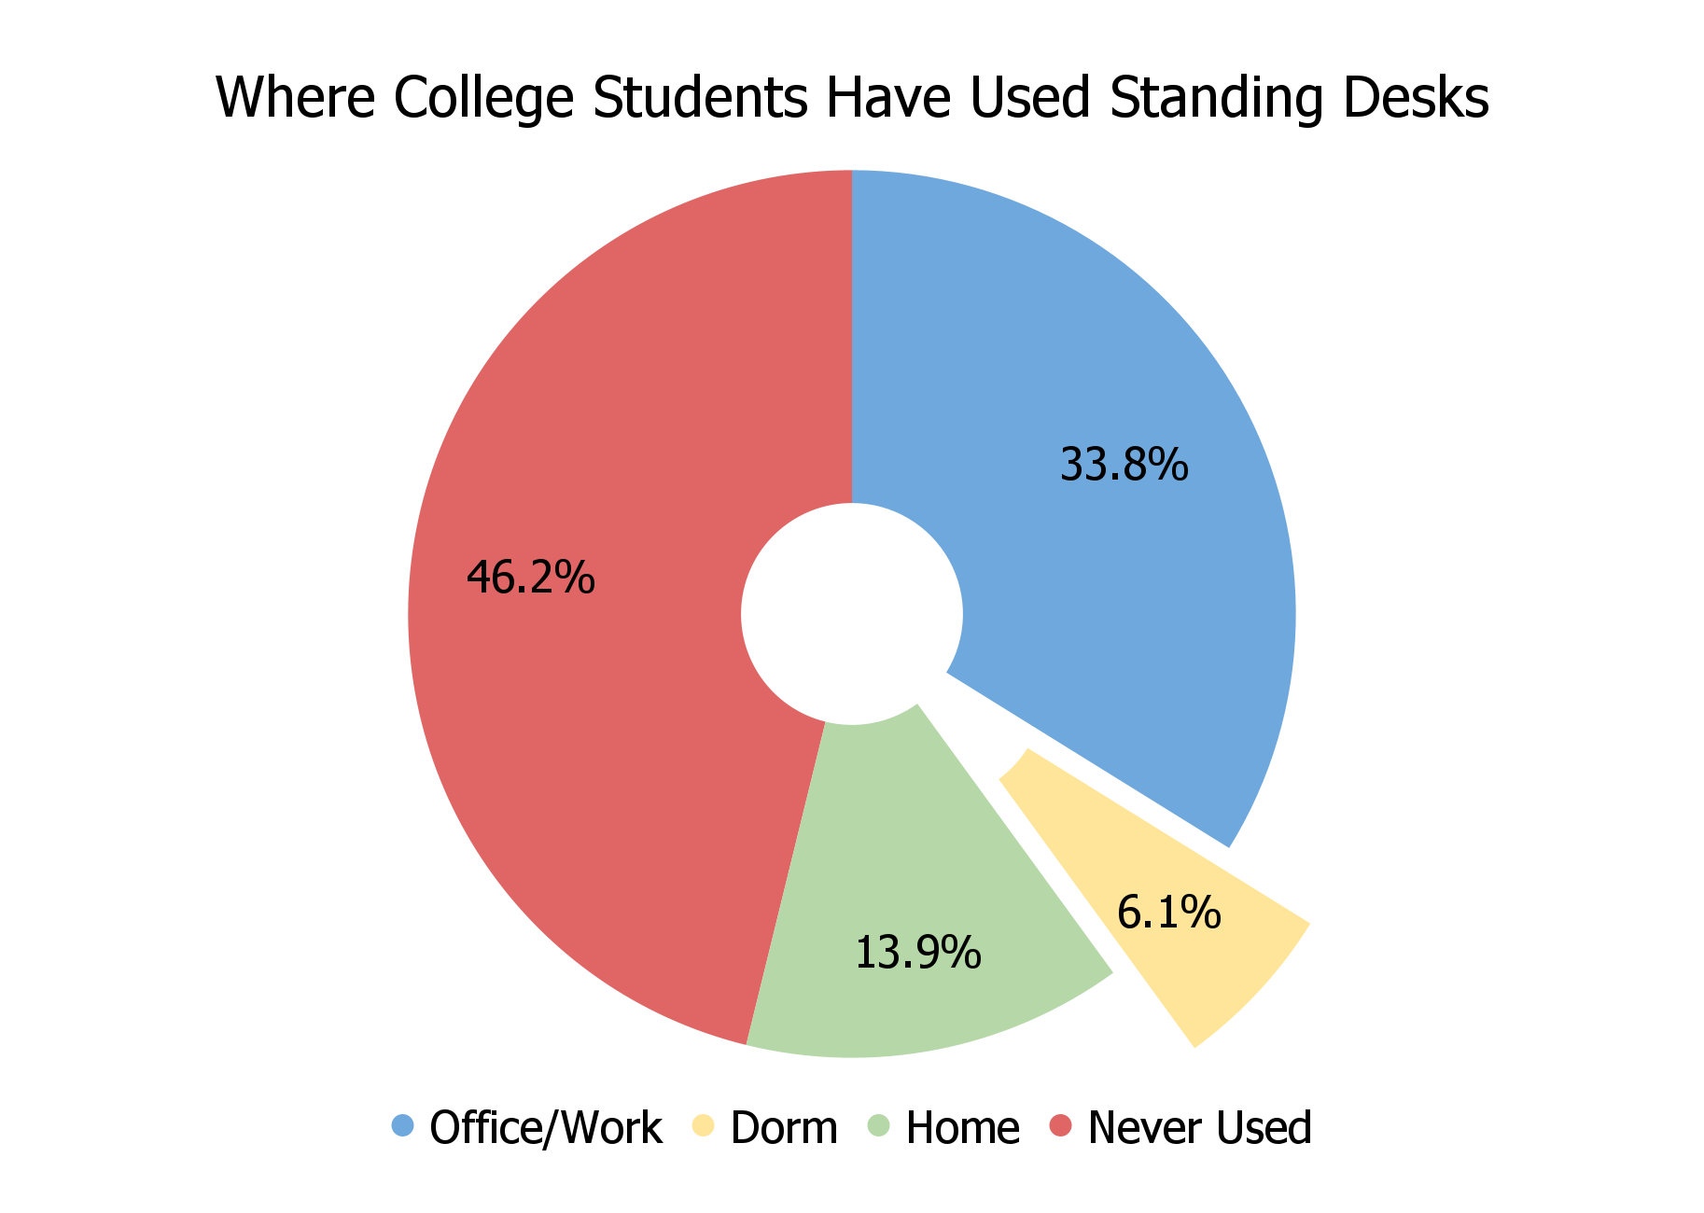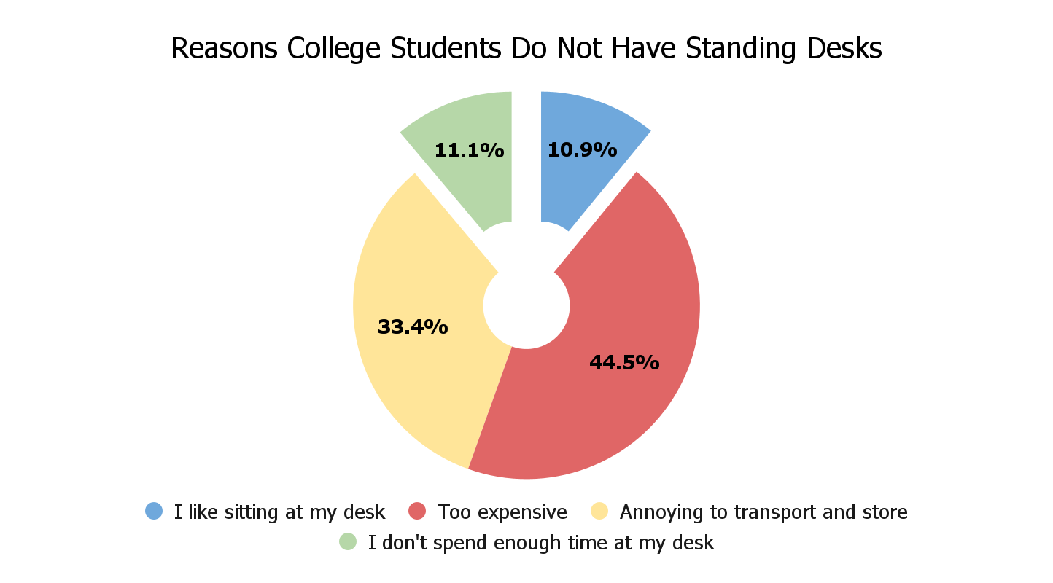

**Figure 1.** Standing desk survey data from college students

We seek to offer a well-suited alternative to current standing desk offerings for college students and other potential standing desk users by considering their true needs and desires. These customers want a solution that provides the full capabilities of a true standing desk while remaining affordable and portable. Our product, ELEVATE, strives to find a solid customer base in these customers by providing the same functionality as a true standing desk while being more affordable and maintaining the portability of a tabletop standing desk converter (see Figure 2).

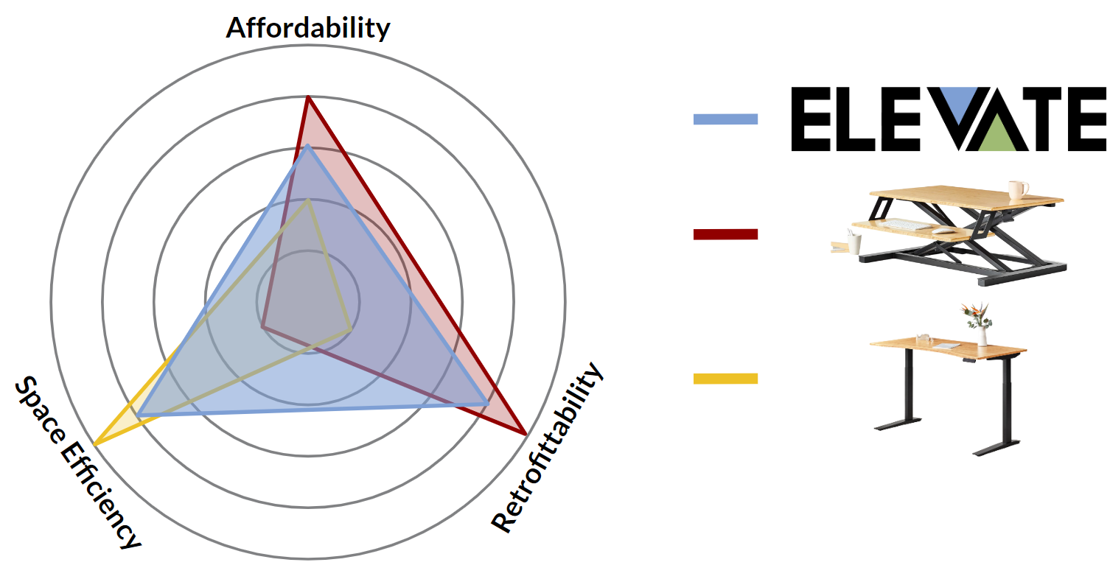

**Figure 2.** A comparison between the capabilities of our product (blue), a tabletop standing desk converter (red), and a true standing desk (yellow)

ELEVATE is a portable, retrofittable standing desk converter that allows the majority of traditional desks to be easily converted into a standing desk. It has the same performance as a traditional standing desk with the added benefit of being cheaper and more portable by taking advantage of the fact that our stakeholders do not necessarily need a new desk. Our customer base includes potential standing desk users that move desks regularly, want to keep their existing desk setup, have a unique desk that cannot be replaced with current standing desk offerings, and/or want a more affordable standing desk solution.

## I.I. Social Impacts of the Solution

As a standing desk solution, ELEVATE provides numerous physical and mental health benefits[1], [4] and makes them accessible to a wider customer base. As ELEVATE is more affordable than alternatives, it also has the possibility of catering to customers in a wider range of socioeconomic statuses. Furthermore, since ELEVATE promotes reusability as it is designed to be used with an existing desk rather than replacing it, ELEVATE has the potential to reduce consumer waste.

We are currently unaware of any global, cultural, or social factors that ELEVATE may contribute to, as the standing desk market does not impact them.

# II. Characteristics

The functional characteristics of ELEVATE are dictated by the need to offer identical performance to that of a traditional standing desk. For this reason, we set ELEVATE’s target functional characteristics to be equivalent to the average performance of standing desks from leading manufacturers such as Herman Miller (formerly Fully)[5] and Uplift.[6] ELEVATE must have a lifting capacity of at least 300 [lbs], and it must be capable of a lifting speed of 0.5 [in/sec]. It also must have at least 1.5 [ft] of height adjustability, and an added requirement as a standing desk converter is that it must not increase the static height of the desk by more than 1 [in]. The last requirement is necessary to ensure that the desk is still comfortable to use when sitting. The lifting capacity accounts for the weight of a heavy desk with common accessories on the desktop like computers and monitors, while the height adjustability allows for a reasonable height range that is suitable for sitting and standing for the general populace.

ELEVATE must also cost the customer less than $300. This price point makes ELEVATE more expensive than most tabletop standing desk converters but cheaper than mid-range and high-end true standing desks. Since ELEVATE provides the same capabilities as a true standing desk, the $300 price point makes it competitive with current market offerings.

As a standing desk solution, ELEVATE will be customer-facing, subjected to loading, and be in the proximity of liquids and debris. To ensure the reliability of ELEVATE, it must be rated for an appropriate amount of mechanical and electrical load cycling for a 5-10 year life cycle. It must also have an IP62 rating for protection against water and dust ingress, which is expected from typical customer usage. It must also have the required electronic product safety certifications for sale in the US, which includes UL consumer product ratings.

To provide a safe customer experience, ELEVATE requires a non-backdrivable solution to prevent unwanted movement when electrical power is lost. It also needs to have a rigid connection to the desk to prevent desk swaying and tipping. The movement system must also be stable to prevent objects or the desk itself from falling.

To accommodate our wide customer base and their various desks, ELEVATE needs to be compatible with >75% of existing traditional desks. Furthermore, to be portable for the user, ELEVATE must weigh less than 35 [lbs] and have a total footprint less than 36 [in] x 27 [in] x 5 [in], which allows it to compete with top-of-the-line tabletop standing desk converters when it comes to portability.[7]

To meet the needs of customers that lack a technical background, ELEVATE must have simple and reliable controls and a simple and easy installation process. Every customer should feel at least as confident setting up ELEVATE as they would setting up a traditional standing desk.

## II.I. Design Impact of Standards

As people will routinely interact with ELEVATE, we must comply with various engineering and consumer product safety standards that are necessary for sale in the US. We also want to comply with additional consumer-focused standards with the intent of improving reliability and customer trust. The most important bodies of standards for our product are those belonging to Underwriter Laboratories, known as UL listing, which is a third party electronics certification company whose standards are commonly held as a requirement in order for electronic products to be sold by most US sellers. Of the UL set of standards, four in particular are highly relevant to ELEVATE. These are UL 1876[8], a standard for isolating signal and feedback, UL 506 [9], a standard for DC-DC components in consumer electronics, UL 60065[10}, a standard for safety requirements of electronic apparatus, and UL 2097[11], a standard for double insulation systems for use in electronic equipment.

Adhering to UL standards introduces some interesting design considerations. Most, if not all electrical components, and particularly the high-power ones, in ELEVATE must be UL listed. This means we can either purchase off-the-shelf electrical components that are UL listed or create our own electrical components, which gives us more control over form, function, and cost, and get them UL listed. Getting a custom electronic UL listed requires: determining applicable standards, preparing documentation including schematics and test reports, submitting and processing an application with applicable fees, and testing and evaluation by Underwriter Laboratories. This process is complicated, expensive, and can take several months, so we must carefully consider the cost of getting custom components UL listed. Thus, any custom electrical component must offer significant advantages to warrant the long UL certification process.

In addition to UL standards, the other main US regulatory requirements we may need to consider are those of the FCC that pertain to the proper handling of radio-frequency energy emission. These FCC standards will become important if we implement any form of wireless communication in our product. While we intend to only use wired forms of communication, we are interested in the possibility of adding wireless support to our product, likely via Bluetooth, to enable app control. If we add this feature in future development, we would be forced to comply with FCC standards. This could be satisfied by purchasing off-the-shelf Bluetooth components that are already FCC compliant.

We also intend to comply with the IP62 standard, which dictates that our solution must be able to withstand dust and water spray. We choose to meet this standard as our solution will be near a desk and liable to be accidentally spilled upon with beverages that a user may have on their desk. Additionally, the dust-resistant aspect of the IP62 rating will account for the possibility that our solution will sit on the floor and should be able to withstand routine dust exposure without shorting or seizing.

# III. Design, Engineering, and Realization

In the materialization of our system characteristics into engineering designs, we began by doing general first-order analysis to ensure that our power requirements and rough sizing are feasible considering our rough cost and packaging goals. We began by calculating our system power by looking at the rate of change of gravitational potential energy of our maximum payload. The solution is expected to be able to lift a maximum load of 300 lbs (136.1 kg) at a minimum rate of 1 in/s (0.0254 m/s). Using this worst case scenario, the maximum required power can be calculated. *E* is energy in J, *m* is mass in kg, *g* is gravitational acceleration in m/s2, *h* is height in m, *P* is power in W, and *T* is time in s.

| $ΔE=mgh$ | (1) |
| --- | --- |
| $ΔE=136.1kg×9.81m/s^{2}×0.0254m$ | (2) |
| $ΔE=$ 33.9J | (3) |
| $P=ΔE/T$ | (4) |
| $P=33.9J / 1s$ | (5) |
| $P=33.9W$ | (6) |

Since the solution will lift the desk at 4 points, the power required for each lift is 8.5W. 15W of power per lift accounts for inefficiencies and safety factors, which is a reasonable wattage for electric DC motors. For added safety, it was planned that in case of vertical overload, the motors would stall long before the structure failed mechanically.

In parallel to our first-order analysis was our down-selection of our lifting mechanism. That is, given our system characteristics, we analyzed which of the following mechanism architectures would most effectively suit our needs: cascade lift, hydraulic cylinders, pneumatic cylinders, rack and pinion, scissor lift, and lead screw. Through research we created a design matrix that helped us come to conclusions about the suitability of each architecture for our system. While cascade/continuous lifts were compact and offered unmatched small packaging, they were not rigid and were backdrivable. Hydraulic cylinders are simple, but it is expensive and obtrusive to run hydraulic tubing to each leg. Pneumatic cylinders required compressed air and would need a bulky and expensive compressor. Gas cylinders, while simple, would be difficult to synchronize the lifting of all four at the same time. Rack and pinion mechanisms were simple, but they had a lot of slop and backdrivability. Scissor lifts offered minimal packaging similar to cascade lift, but with much more complexity than would be feasible for a cheap, mass-producible product. We ended up choosing lead screws as they required very few moving parts, provided a simpler packaging solution, and offered strong, precise, and non-backdrivable motion, which all fit conveniently into our design criteria.

Choosing to implement a lead screw design included the fact that we would drive the lead screw with a worm-gear gearbox. We chose to use a worm-gear drive train for a few reasons. First and foremost, it further guaranteed our system’s non-backdrivability, as the very high gear reduction combined with the sliding action inherent to worm-gears mean backdrivability is nearly impossible without first deforming metal parts. Secondly, a worm-gear would handle the entirety of our relatively large gear reduction (from a typical DC brushed motor) with only two gears, minimizing the number of gears, the amount of backlash stackup in the system, and, thus, the total slop and wobbliness of our risers. Finally, the perpendicularity of a worm gear’s input and output axes means our motor would lie flat against the ground, both improving our packaging and lowering our CG height, increasing stability. We later learned from teardowns of competitors’ standing desks that this DC-motor worm-gear-driven lead screw setup is more or less industry standard, which was positive affirmation that our design process was working as intended.

We knew from our first-principle calculations that our motors would need to hit roughly 15W peak power each. In an effort to avoid unnecessary added cost and complexity of finding and fitting a custom worm-gear gearbox to a motor, we decided to look for motors that had the worm-gear gearbox included and already integrated. Once we knew that we wanted 15W worm-gear DC motors, we had to decide on other specs like output RPM, torque, voltage, and current. RPM and torque were most directly related to our system characteristic goals of 0.5in/s lift rate and 300 lb max weight capacity, so we started with those. We iteratively paired potential motor options and with lead screw options, finding good compatibility between motor RPM and torque with lead screw thread starts and TPI to hit our desired performance. Ultimately, we chose the AndyMark am-2235a snow blower motor, which is 12V and roughly 4A max continuous. These two electrical parameters then defined the electrical system architecture.

## Leg Holder Design

A survey of table legs was conducted by searching through popular desks on Costco, Ikea, and Office Depot. The survey yielded the following results.

| Circle | Square | Rectangle | Board |
| --- | --- | --- | --- |

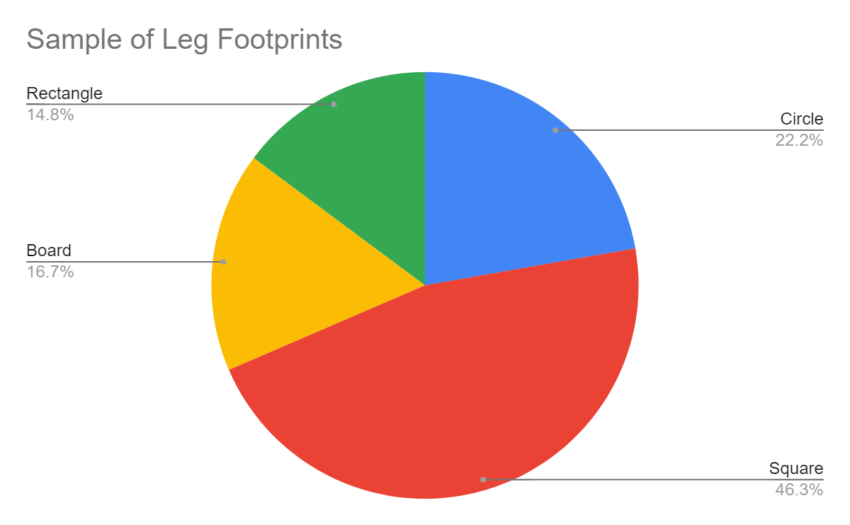

**Figure 3.** Distribution of desk leg footprints

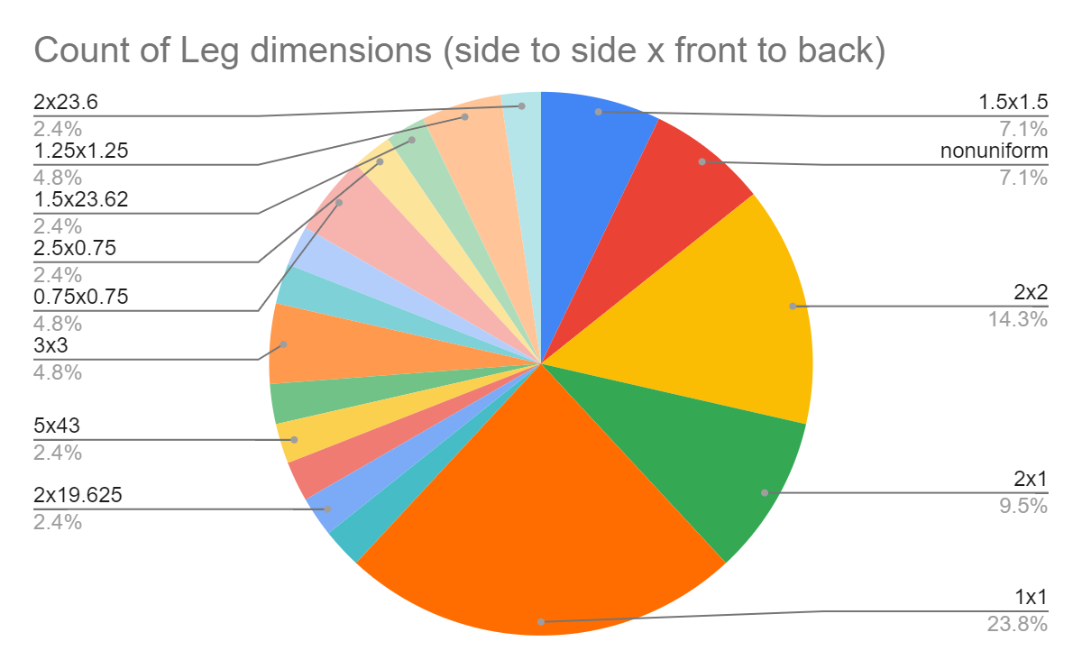

**Figure 4.** Distribution of desk geometries

The survey revealed that most desk legs had circular, rectangular, or square legs, with the rest (16.7%) having legs that were boards. Additionally, all of the legs that were not boards had footprints that could be captured by a 3” x 3” square. This was good news for ELEVATE, since this meant that a leg holder platform that was a 3” square would be able to capture an estimated 80% of desks. This square could still hold legs that are boards, but there would be nothing for the straps to wrap around and secure the desk to the ELEVATE unit. The universal strapping feature is provided by a ratcheting belt, similar to that on the top of a snowboard boot.

## Initial Plastic Prototype

In order to achieve a working prototype as fast as possible, the parts that had complex machining methods were printed using ABS. This allowed us to have a full prototype that could move and test, albeit not under normal use case loads.

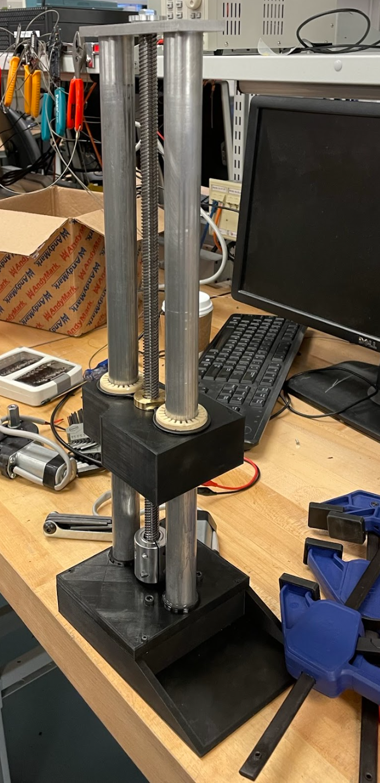

**Figure 5.** Initial plastic prototype had high mechanical play and high current draw

The initial prototype confirmed that the parts fit together, and that the initial electrical geometry was sound. And, indeed the unit was able to elevate and deescalate without load. However, we saw that the unit was drawing quite a considerable amount of current as it elevated.

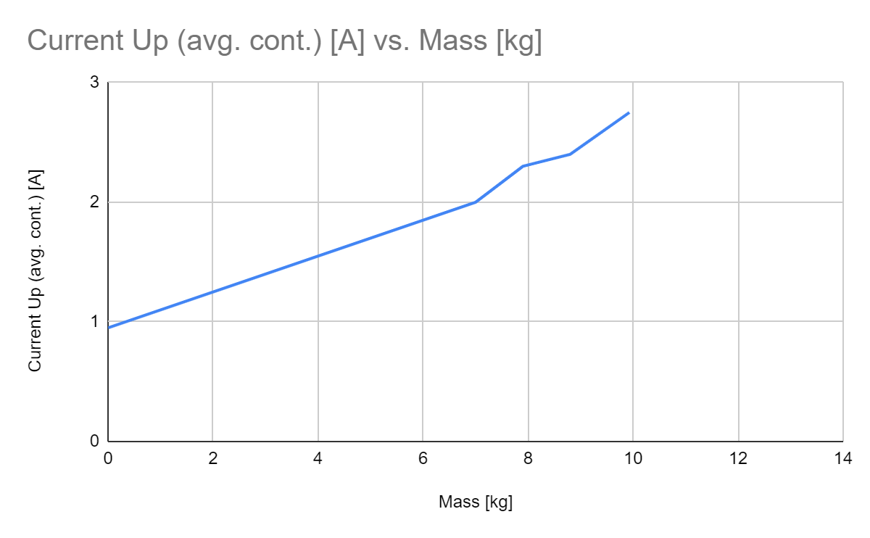

**Figure 6.** Current draw of plastic prototype at different vertical loads

Even at no vertical load on the unit, the unit was drawing 1 amp. Previous motor testing showed that a free spinning motor would draw about 0.5 amps. This meant that something was rubbing and binding in the system as it translated vertically. Measuring the 3D printed parts with calipers, it was found that the parts were slightly out of tolerance, which meant that there was more than expected rubbing on the sleeve bearings. We then decided to continue onwards to making a full metal prototype, since machining tolerances are much better than 3D printer tolerances.

## Full Metal Prototype

The full metal prototype was machined and assembled, and the no vertical load current on the motor dropped significantly to 0.85 amps.

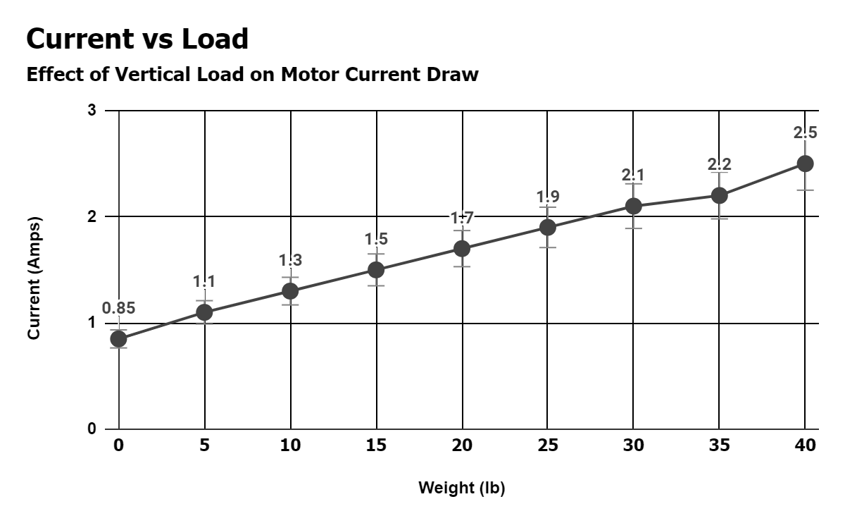

**Figure 7.** Current draw of full-metal unit at different vertical loads

This validated that our machining methods provided tolerances that were acceptable, so the rest of the parts for 3 more units were machined.

## Electrical System

The electrical system was required to fulfill two roles: system control and power delivery. System control included the implementation of user controls, height control, and safety features. For the user interface, we settled on a two-button panel for its simplicity and ubiquity. With different button press combinations, the user could lift, lower, and calibrate the system. The button panel circuit is shown in Figure A.7. To control height, it was necessary that the system was capable of both measuring and adjusting speed. For speed measurement, we selected magnetic absolute encoders as they were simple to install and reduced the number of mechanical points of failure. We used DC motor drivers rated for the proper voltage and current to control speed. For electrical safety reasons, we needed to be able to determine when the system reached a physical height limit, and limit switches were an inexpensive and reliable solution. Once we determined the necessary sensors for the system, we had to decide how to process the signal data. We chose to use a single central MCU to handle system control as it was cheaper, simpler, and more power efficient than using multiple MCUs and we did not need additional IO or compute power.

Power delivery requirements were dictated by the DC motors. The motors we selected were rated for 12V, and since the speed control would reduce the effective voltage, we designed the system to be powered by a single 15V power supply. The motor drivers could take the 15V directly, but the MCU required 5V for power and 3.3V for logic. Thus, we needed a power distribution board that could take 15V as input and output 3.3V, 5V, and 15V. The power distribution circuit is shown in Figure A.10 and the PCB is shown in Figure 8.

# 

**Figure 8.** Power distribution board PCB render

After the necessary electrical components were determined, we had to decide how power would be delivered to the motors and sensors and how data would be delivered to the MCU. Signal delivery between the sensors and the central MCU could use either wired or wireless communication, with the former being simpler, reliable, and more power efficient. Furthermore, power delivery to the risers required physical wires between the PDB and the risers, so it also made sense to use physical wires for signal delivery, since the system could no longer be made fully wireless. Since each riser contained many electrical parts that required independent electrical lines, a splitter board was designed and fabricated. The splitter circuit is shown in Figure A.8 and the PCB is shown in Figure 9. The overall electrical architecture is shown in Figure A.6.

# 

**Figure 9.** Splitter board PCB render

During testing of the full system, we discovered that wired encoder data transmission was extremely unreliable. This issue occurred because we were trying to send I2C signals over unshielded 10 foot cables that were adjacent to motor power cables. The motor power lines generated a significant amount of EMI, which was exasperated by the lack of wire shielding. Furthermore, I2C is a communication protocol that is notoriously unreliable over distances greater than 6 inches. To circumvent this issue, we modified our electrical architecture to use multiple MCUs, with one central MCU and an additional MCU in each riser. This allowed us to transmit data wirelessly between MCUs and completely remove wired communication.

During the design process, we realized that synchronizing the multiple risers would be much more challenging than we initially anticipated. When the risers lifted or lowered, we could not just sync their speed, as small speed differences could lead to large differences in height. Therefore, we had to sync the riser heights while in motion. To achieve the desired height control, we decided to use a PD controller. The PD controller was selected because it was the simplest control algorithm that was capable of following the desired linear height trajectories.

The system control software was written completely from scratch in C++. Key features include a custom variable delay switch debouncing method and a custom PD controller. The software worked by continuously updating the desired system state and changing the instantaneous desk speed to match the desired system state. The software processed signals from the limit switches and button panel to determine the desired system state. Then, the software sent an instantaneous height command to each of the risers, which was received by the PD controller that controlled the motor speed.

# 

# IV. Final System Form

# 

**Figure 10.** Final ELEVATE form breakdown

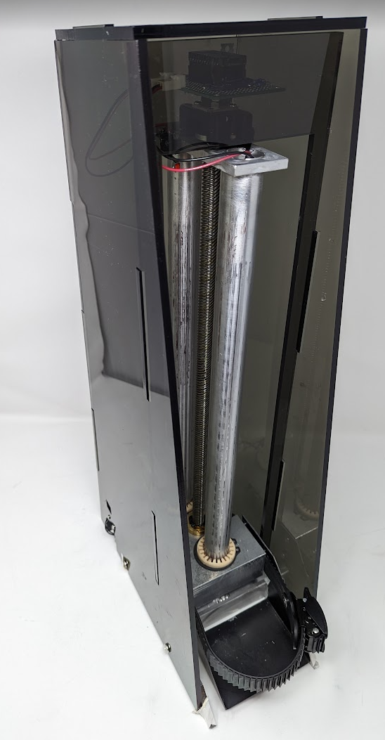

**Figure 11.** Final prototype of an ELEVATE riser unit

Our final prototype did end up achieving the general functionality we would expect of our final product, including weight capacity, stability, and responsiveness. Where it was most in need of improvement, however, was the general appearance, packaging, and enclosures. While the current enclosures perform their basic functions of keeping dust, liquids, and fingers out, they are large and have a very brutalist appearance. However, refactoring mechanical elements to accommodate for a slim appearance is mechanically possible. For a mass-produced ELEVATE, we would seek to reduce our enclosure part count from 5 assembled laser-cut acrylic panels to two injection-molded parts. This would cut down significantly on manufacturing time and allow for more complex and space-saving shapes, at the cost of requiring mass quantities to justify expensive molds.

## Leg Mounting

The ratchet straps that were used to connect the legs to lift assemblies functioned as advertised, as they were able to achieve high clamping forces with low user effort thanks to its latching mechanism. However, since the strap was designed to accommodate legs up to 3 inches in diameter, the strap had difficulty attaching to legs that were 1 inch in diameter since the buckle wrapped around the leg and interfered with the shroud. Therefore, a foam spacer was made to push the leg a small distance outwards so that the strap could be properly accessed. In future versions, the strap should be placed closer to the mounting points so that no spacer is needed.

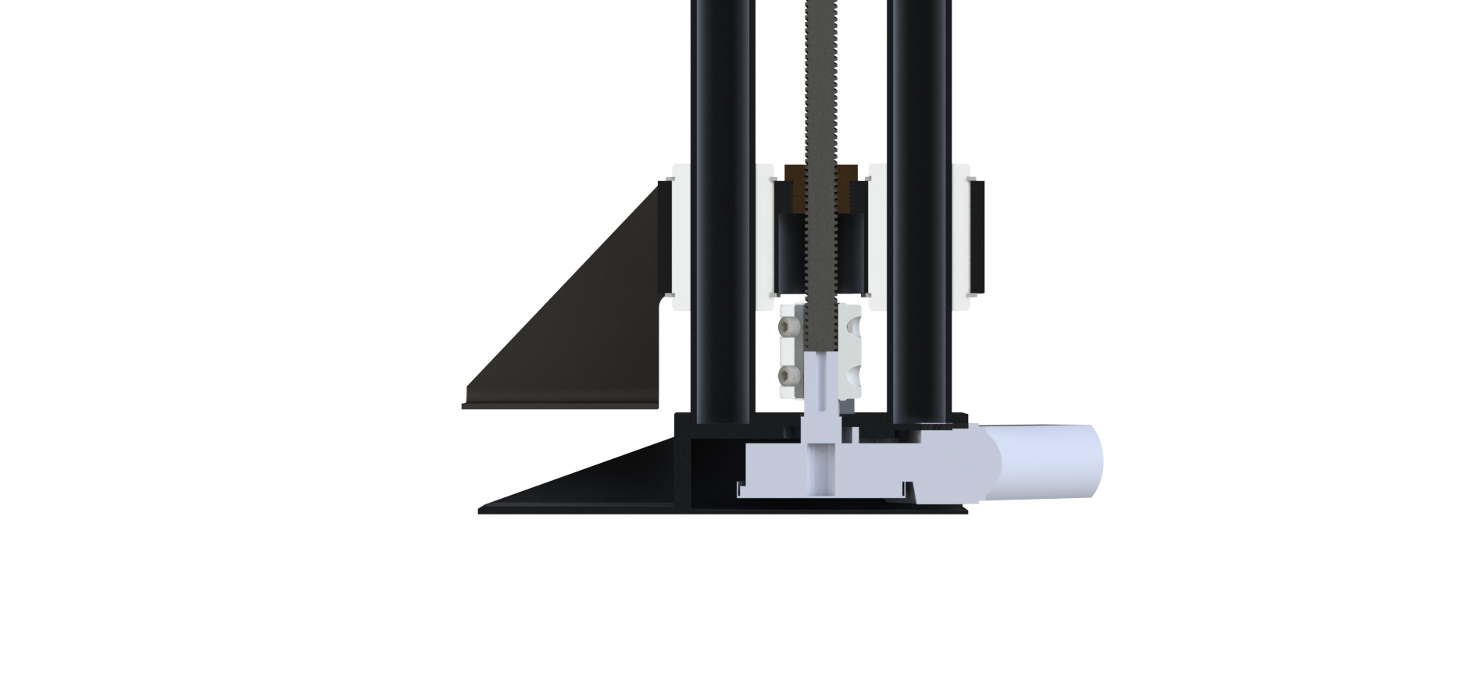

**Figure 12.** Internal interfaces of motor, housing, and lead screw assembly

## Design for Manufacturing

The final system form also differed from the original design in that the motor housing and baseplate assembly was split into four different parts, instead of being one part. Although this increased part count, it significantly decreased machining time, as four 2D components assembled together is much simpler and easier to machine than a single complex part. But besides this revision, the rest of the assembly stayed the same, as the workgear gear box, the sleeve bearings, tubes, and floating shaft collar all performed nominally.

## Floating Lead Screw Coupler

One innovation that we want to point out is the floating hex coupler that connects the motor drive shaft to the lead screw. Loading the lead screw in compression when a table is placed on the system would place thrust load on the motor, which is not specified to take thrust load, and loading the lead screw in compression would also risk buckling the lead screw. As a result, the lead screw is coupled to the motor with a coupler that does not constrain the lead screw vertically by the motor. Instead, the lead screw hangs from the top structure through a disk and thrust bearings. This puts the two thicker aluminum rods in compression rather than the weaker lead screw.

## Electrical Architecture

The final electrical architecture is shown in Figures A.7 and A.11 - A.14. The desk panel contained the two-button panel, the main central MCU, the motor drivers, and the power distribution board. The control panel and electronics enclosure of the final system was rudimentary. The desk panel electronics enclosure was a laser-cut acrylic box and extremely large for its intended purpose and form factor. This was done to have easy access to the MCU for debugging and because the hand-wired nature of the electronics made it difficult to package them together. The final product would be much smaller with the MCU, motor drivers, and PDB consolidated into a single PCB.

Due to the last minute conversion from wired to wireless communication, we were unable to achieve our goal of powering the entire system from a single 15V fixed power supply. Instead, two 15V power supplies were connected to the PDB, which was used to pass power to the motor drivers. A 9V power supply was connected to a mutual power rail to supply power to all the riser MCUs, and a 5V power supply was used to power the central MCU. Power for the riser MCUs and motors was delivered from the desk panel to the risers using 4-wire unshielded connectors. In each riser, the 4-wire input was split to power the motor and the riser MCU, and the riser MCU was connected to 2 limit switches and the encoder.

To control the system, the user presses the up button to move the desk up, the down button to move the desk down, and both buttons to calibrate the system height.

# V. System Performance

In testing, our prototype achieved nearly all of our performance requirements. When properly clamped to a folding table, our prototype easily lifted our maximum load capacity of 75 [lbs] per riser, maintained a consistent 0.5 [in/sec] lifting rate, and remained level even with eccentric loading. A video of this testing session can be found at this [link](https://youtu.be/opz3blI0Zd4),1 and Figure 13 shows the prototype lifting 150+ [lbs].

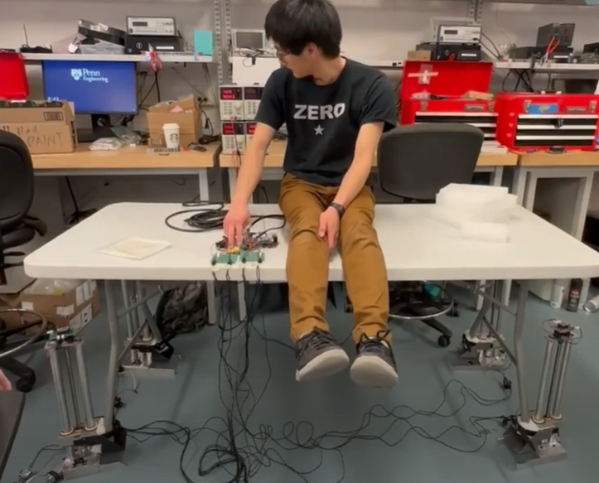

**Figure 13.** Prototype lifting a 127 [lb] individual on a folding table

Furthermore, when at any height including maximum height, the desk and our risers were acceptably stable and proved to be nearly as difficult to tip over as a traditional desk. With the desk at maximum height, we performed a range of expected loading scenarios, which included placing heavy weights on the table, leaning on the table, and bumping into the table and legs. The system did not deflect beyond an acceptable range and remained standing and upright throughout the entire experiment. Although this was an entirely qualitative user-experience test, we were able to gain an initial impression of the stability and rigidity of our prototype. Additionally, throughout this rough physical testing, the system experienced no backdriving, which validated our mechanical system architecture design. Noise from the motors did not exceed the noise levels of top-of-the-line standing desks. While the motor noise was audible, the noise level was noticeably lower than that of other standing desks, which is likely due to the fact that full standing desks tend to have motors mounted directly under the desk, whereas ELEVATE’s motors are at floor level.

When the system was loaded with approximately 150 [lbs], each riser drew a maximum of 2.5A at 15V, which is equivalent to a 90W power draw. This was significantly above our estimate of 30W, and could be attributed to losses in friction at sliding interfaces like the bearings and lead screw, as well as electrical losses in the long cabling and in the motors.

The final weight of each riser prototype was 6 [lbs], which undercut our original target of 7.5 [lbs]. Thus, our final system came in at a net weight of 24 [lbs].

To analyze the performance of our control algorithm, we measured the deviation of each riser height from a shared desired trajectory. Our test trajectory featured a ~9 second lift phase followed by a ~4 second stop phase followed by a ~9 second lower phase and ended with a ~4 second stop phase. This target trajectory can be seen in Figure 14 along with the trajectory of each riser. While the riser trajectories were clearly shifted from the target trajectory, this was expected due to the inherent timing delay built into the software. It can be seen that the PD controller was actually extremely effective as each riser closely followed the target path. The error between each riser trajectory and the target trajectory can be seen in Figure 15. The absolute error rarely exceeded 0.1 [in], which we considered acceptable, and more importantly, the riser height errors were extremely clustered, which suggested that the system was balanced throughout the entire trajectory. Figure 16 shows the maximum height error between the risers throughout the trajectory. It was observed that the error between any pair of risers never exceeded 0.035 [in], which confirmed that the system remained extremely level and balanced even while in motion. Thus, we were able to determine that our control algorithm was highly effective at achieving our desired desk height trajectory and maintaining levelness both in motion and at standstill.

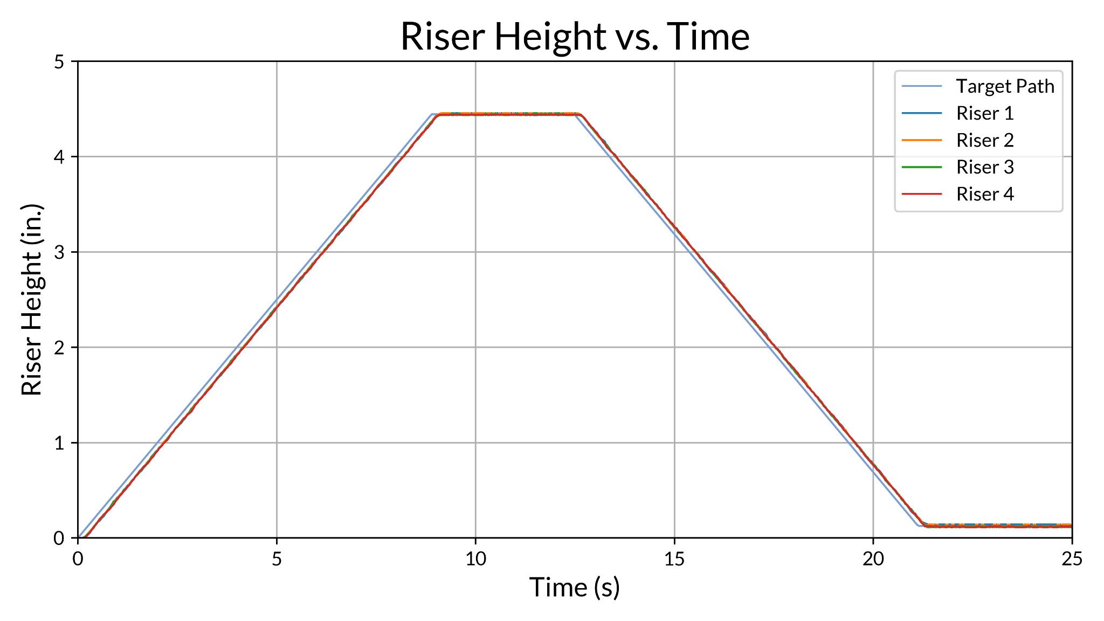

**Figure 14.** Comparison of target trajectory and all riser trajectories

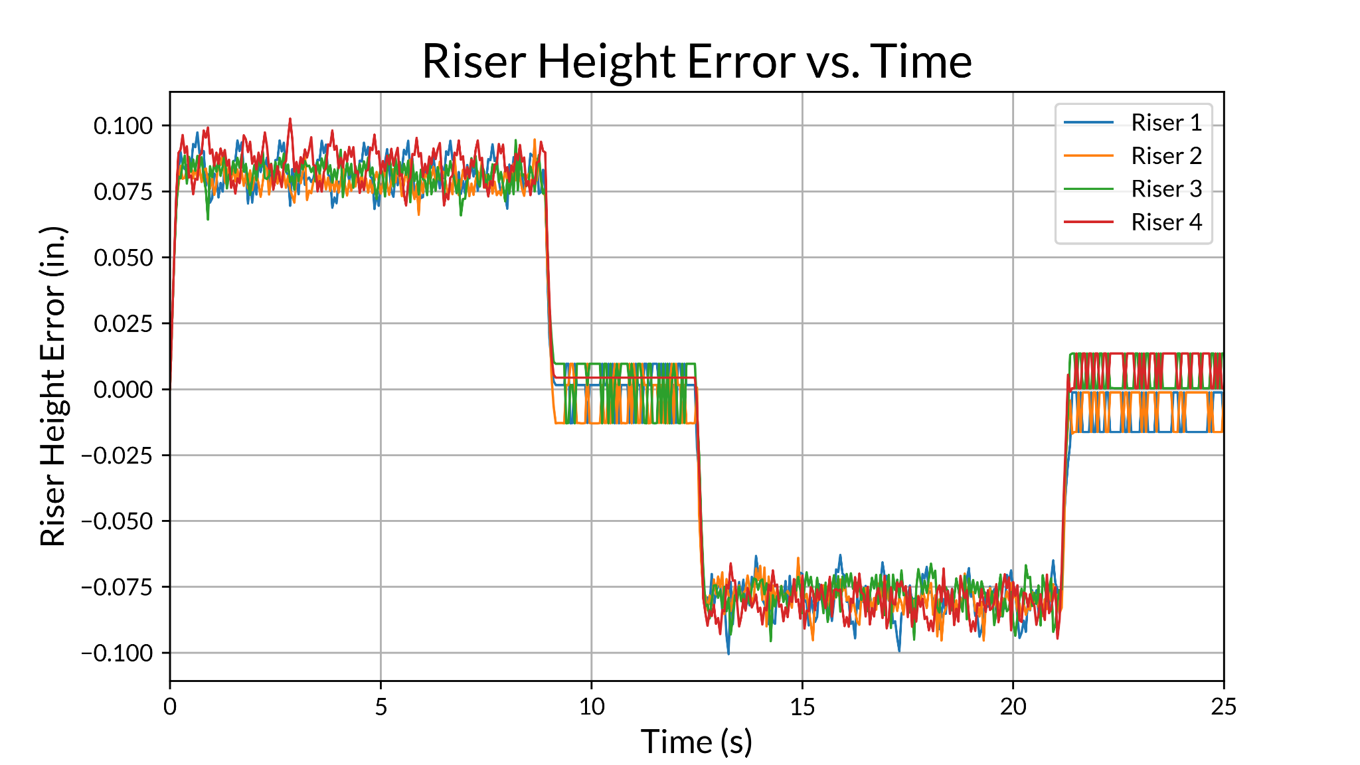

**Figure 15.** All riser height errors from the target trajectory

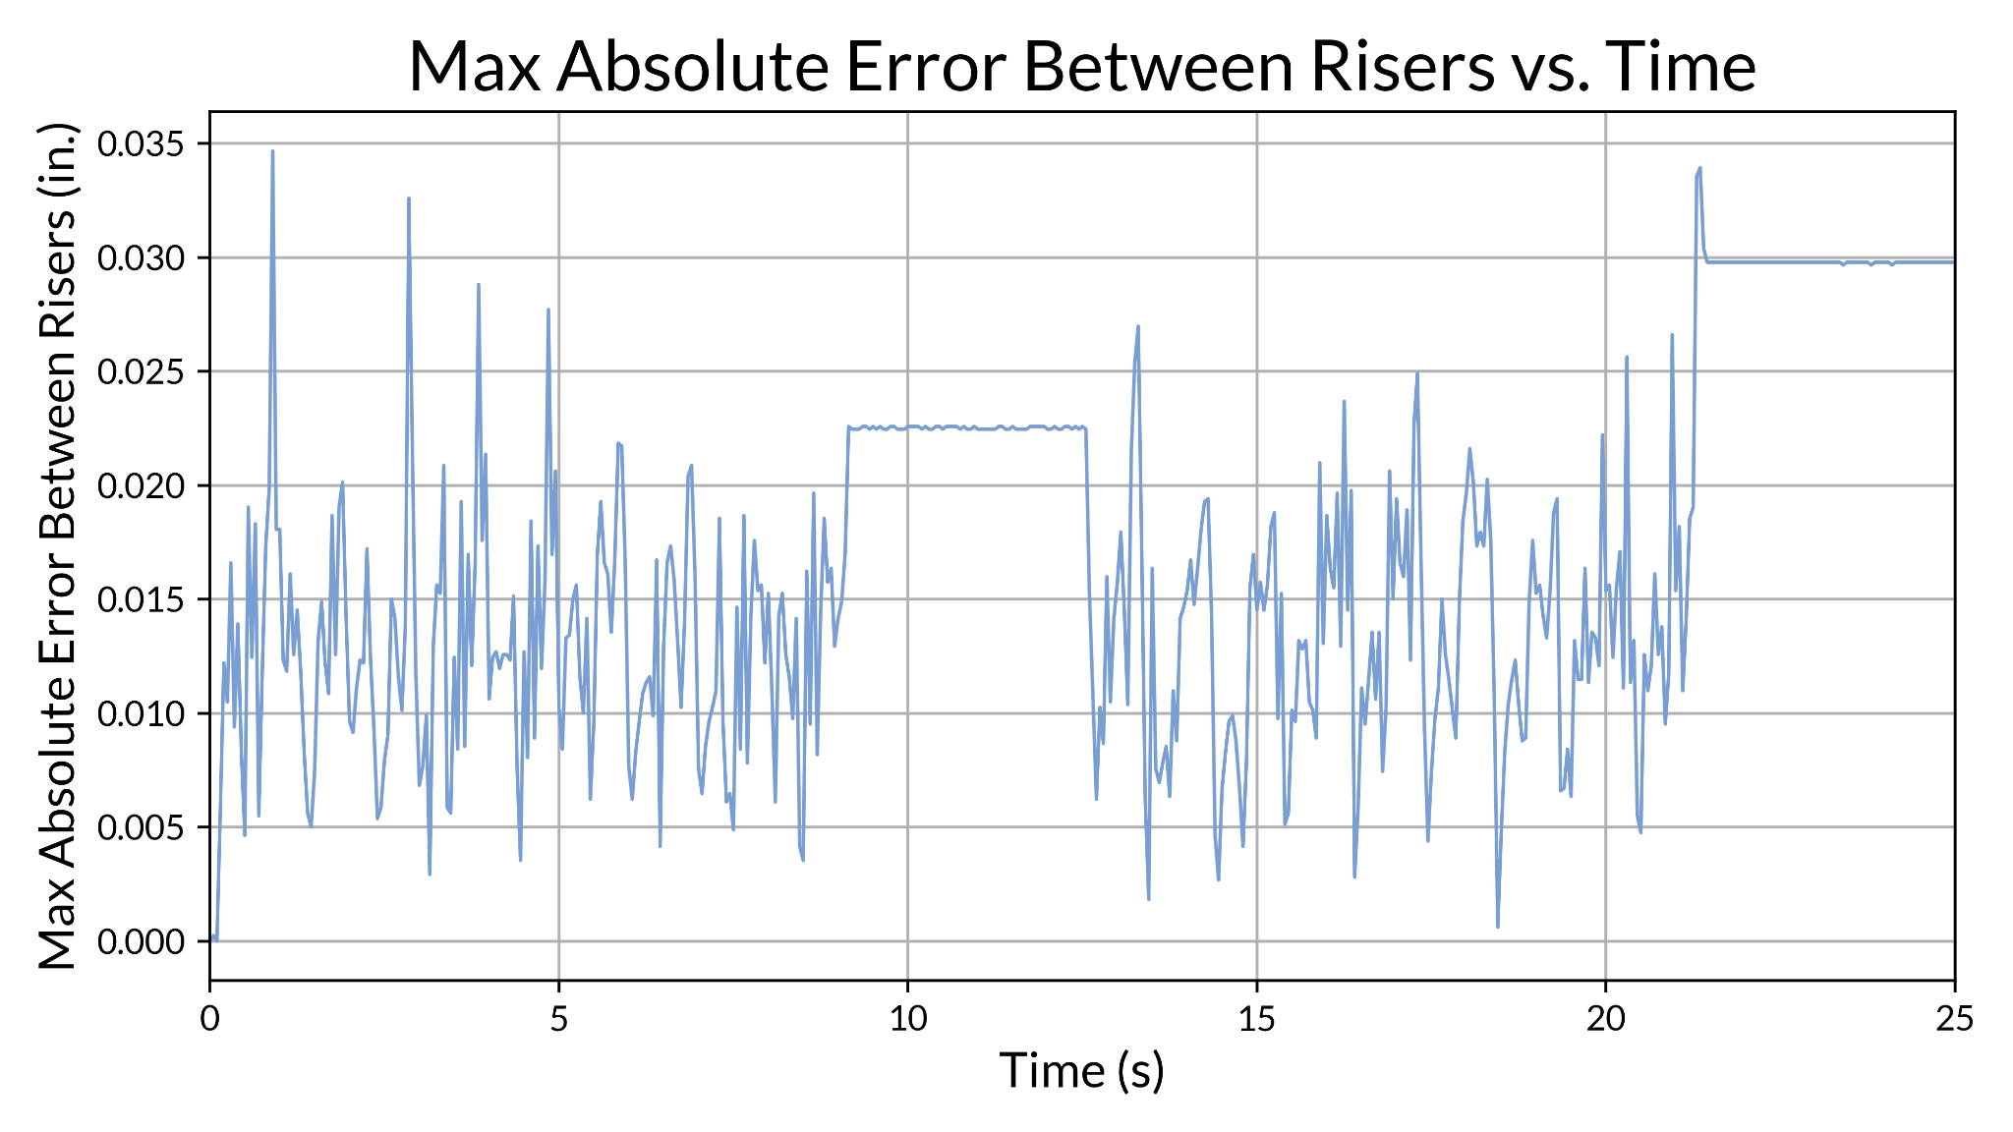

**Figure 16.** The maximum absolute error between all riser heights throughout the entire test trajectory

# VI. Conclusions and Future Work

Throughout the prototyping and manufacturing process, we learned a great deal about 3D printing, including its limitations and associated tolerances and the various materials and their quirks. We also gained more experience with design for manufacturing, as we went through several revisions of our metal components to simplify the manufacturing process.

By working on the electrical system, we obtained a significant amount of knowledge related to electrical architecture and design, circuit board design and best practices, and communication protocols.

The software development for ELEVATE allowed us to gain experience with embedded systems, real-time systems, control algorithms, and C++.

Several mechanical improvements need to be made to ELEVATE to make it an attractive product. The shroud must be slimmed down from its current brutalist form. We can also accomplish additional weight savings by pocketing structural elements with extremely high safety factors, such as the lift runner. A more refined solution for strapping onto desks with different leg widths needs to be made, as the current implementation can only reliably strap onto thick legs. A rubber insert seems to be a viable option. The current system also does not have a handle to lift the unit during transportation.

For the electrical system, the most critical work would be the implementation of reliable wired communication. This would involve using a long-distance differential signal like RS-422 and shielded cables. The next step would be to switch to a single 15V power supply, which is easy to achieve once the riser MCUs are no longer needed. A more distant goal would be to consolidate the PDB, motor drivers, and MCU to a single compact PCB, which would reduce the desk panel size significantly and reduce long-term costs.

The current software implementation is relatively robust. One additional feature that should be added is the ability to save current and preset heights. Saving the current height in flash memory would allow the system to remember its absolute height even after power loss and would enable preset heights to function properly. Saving preset heights in flash memory is a nice feature for customers that would allow them to consistently reach their sitting and standing heights without having to manually adjust every time.

Overall, we made a fully-functioning minimum viable product and were able to conclude that the concept is viable from both an engineering and cost perspective. After completing the aforementioned engineering work, the remaining engineering effort to bring ELEVATE to market would be in-depth user testing and feedback, reliability testing, and additional engineering adjustment in response to this testing. On the business side, efficient targeted marketing must be done to quantify production volume and pricing.

# VII. Statement of Roles

**Griffin Addison**

*gaddison@seas.upenn.edu, griffinnosidda@gmail.com*

Mechanical Prototyping, Motion Architecture, Electrical Integration

Griffin was responsible for the selection and design of the motion architecture. This included balancing motor and gearbox specifications with lead screw geometries to hit performance targets, and then sourcing the actual components from vendors. He also designed and 3D printed a variety of components for early prototypes to test packaging and functionality and for sensor and electronics integration, including for the magnetic encoders he selected. He also designed and manufactured all enclosures.

**Darrion Chen**

*darrion@seas.upenn.edu, darrion.chen@gmail.com*

Mechanical Design, CAD, Design for Manufacturing, Machining, and Manufacturing

Darrion was responsible for the full mechanical design of the elevating assembly. This included material selection, fastener selection, and component failure analysis. He then proceeded to CAD the components and assemble them, simplifying parts and reducing part count throughout the process to increase manufacturability. After the CAD was completed, he precision machined and assembled all components to make four assemblies. This was then proceeded by mechanical debugging of all sliding interfaces.

**Jonathan Lee**

*jonlee27@seas.upenn.edu, jcl4.jonathan@gmail.com*

Controls, Electrical Design and Manufacturing, Software Development

Jonathan was responsible for the controls system, electrical system, and software. For controls, he chose, implemented, and tuned the control algorithm to achieve the desired motion for ELEVATE. For the electrical system, he started with the system characteristics and researched the necessary sensors and electronics. Next, he created the necessary electrical circuits to integrate all the electrical components. Then, he prototyped the circuits to confirm their correctness and designed and soldered PCBs for the final product. This process involved several rounds of component selection. He was also responsible for all electrical manufacturing and designed, manufactured, tested, and debugged every circuit and wiring harness. For the software, he devised and implemented, from scratch in C++, the high-level control loop, the method for riser coordination and communication, the PD controller, the low-level sensor data handling, and the motor control.

# 

# VIII. Acknowledgements

We would like to express our gratitude to Joah Kim and Philip Sieg who were our team advisors and who provided invaluable tips and suggestions during our weekly discussions. We would also like to thank Professor Bruce Kothmann, our faculty advisor, who provided valuable feedback and suggestions for mechatronics and software improvements. We also want to thank Professor Graham Wabiszewski, who served as the senior design professor. He provided crucial feedback on both mechanical and presentation-related items. We also want to thank Alex Ge, our electrical engineering consultant, who provided guidance on PCB design, EMI, components selection and general electrical engineering tips.

As ELEVATE is a custom-machined system, we also want to thank the Penn Engineering Precision Machining Laboratory and its staff. Particularly, we want to thank Pete Szczesniak, Peter Bruno, and Joe Valdez for their support in the machine shop and for providing machining advice. We also want to thank Jason Pastor for welding structural elements for our system.

# References

1. J. Ma, D. Ma, Z. Li, and H. Kim, “Effects of a Workplace Sit–Stand Desk Intervention on Health and Productivity,” *International Journal of Environmental Research and Public Health*, vol. 18, no. 21, p. 11604, Nov. 2021.
2. “Standing Desks Market - Size, Trends, Growth and Forecast 2028,” *Credence Research*, Aug-2022. [Online]. Available: https://www.credenceresearch.com/report/standing-desks-market. [Accessed: 03-May-2023].
3. G. Knighton, “How much does an electric standing desk cost in 2023?,” *BTOD*, 20-Feb-2023. [Online]. Available: https://www.btod.com/blog/standing-desk-cost/. [Accessed: 03-May-2023].
4. Autonomous, “What Are the Psychological Benefits of a Standing Desk?,” *Autonomous*, 15-Jul-2021. [Online]. Available: https://www.autonomous.ai/ourblog/psychological-benefits-of-a-standing-desk. [Accessed: 04-May-2023].
5. “Jarvis Bamboo Standing Desk,” *Herman Miller*. [Online]. Available: https://store.hermanmiller.com/standing-desks/jarvis-bamboo-standing-desk/2542428.html. [Accessed: 04-May-2023].
6. “UPLIFT Standing Desk (V2 & V2-Commercial),” *UPLIFT Desk*. [Online]. Available: https://www.upliftdesk.com/uplift-v2-standing-desk-v2-or-v2-commercial/. [Accessed: 04-May-2023].
7. “VariDesk® Essential 36,” *Vari*. [Online]. Available: https://www.vari.com/sit-stand-converter-varidesk-essential-36/DC-EST36.html. [Accessed: 04-May-2023].
8. UL Standard, “Isolating Signal and Feedback Transformers for Use in Electronic Equipment,” *UL Standards & Engagement | UL Standard | UL 1876*, 25-Jun-2015. [Online]. Available: https://www.shopulstandards.com/ProductDetail.aspx?productId=UL1876_4_S_20150625. [Accessed: 04-May-2023].
9. UL Standards, “Specialty Transformers,” *UL Standards & Engagement | UL Standard | UL 506*, 02-Jun-2017. [Online]. Available: https://www.shopulstandards.com/ProductDetail.aspx?UniqueKey=32914. [Accessed: 04-May-2023].
10. UL Standards, “Standard for Audio, Video and Similar Electronic Apparatus - Safety Requirements,” *UL Standards & Engagement | UL Standard | UL 60065*, 30-Sep-2015. [Online]. Available: https://www.shopulstandards.com/ProductDetail.aspx?productId=UL60065_8_S_20150930. [Accessed: 04-May-2023].
11. UL Standards, “Reference Standard for Double Insulation Systems for Use in Electronic Equipment,” *UL Standards & Engagement | UL Standard | UL 2097*, 28-Dec-2006. [Online]. Available: https://www.shopulstandards.com/ProductDetail.aspx?productId=UL2097_4_S_20061228. [Accessed: 04-May-2023].

# Appendix

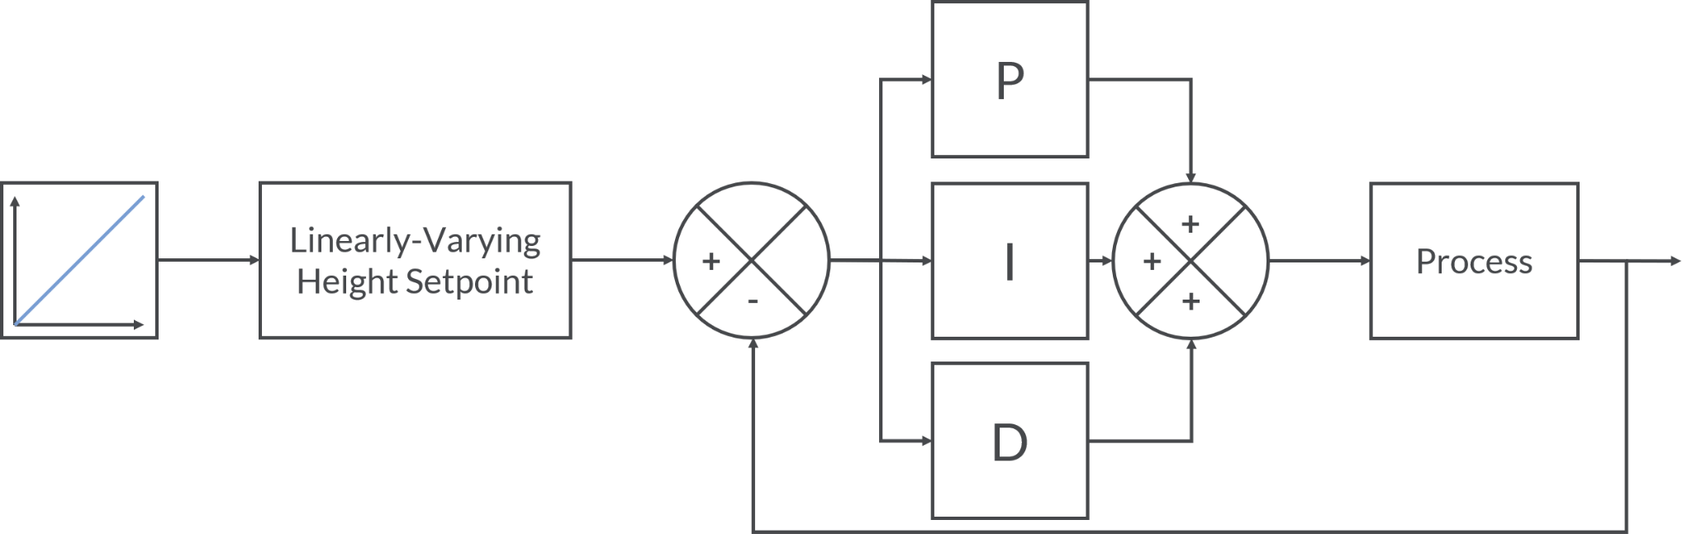

**Figure A.1.** PID control algorithm with a moving setpoint

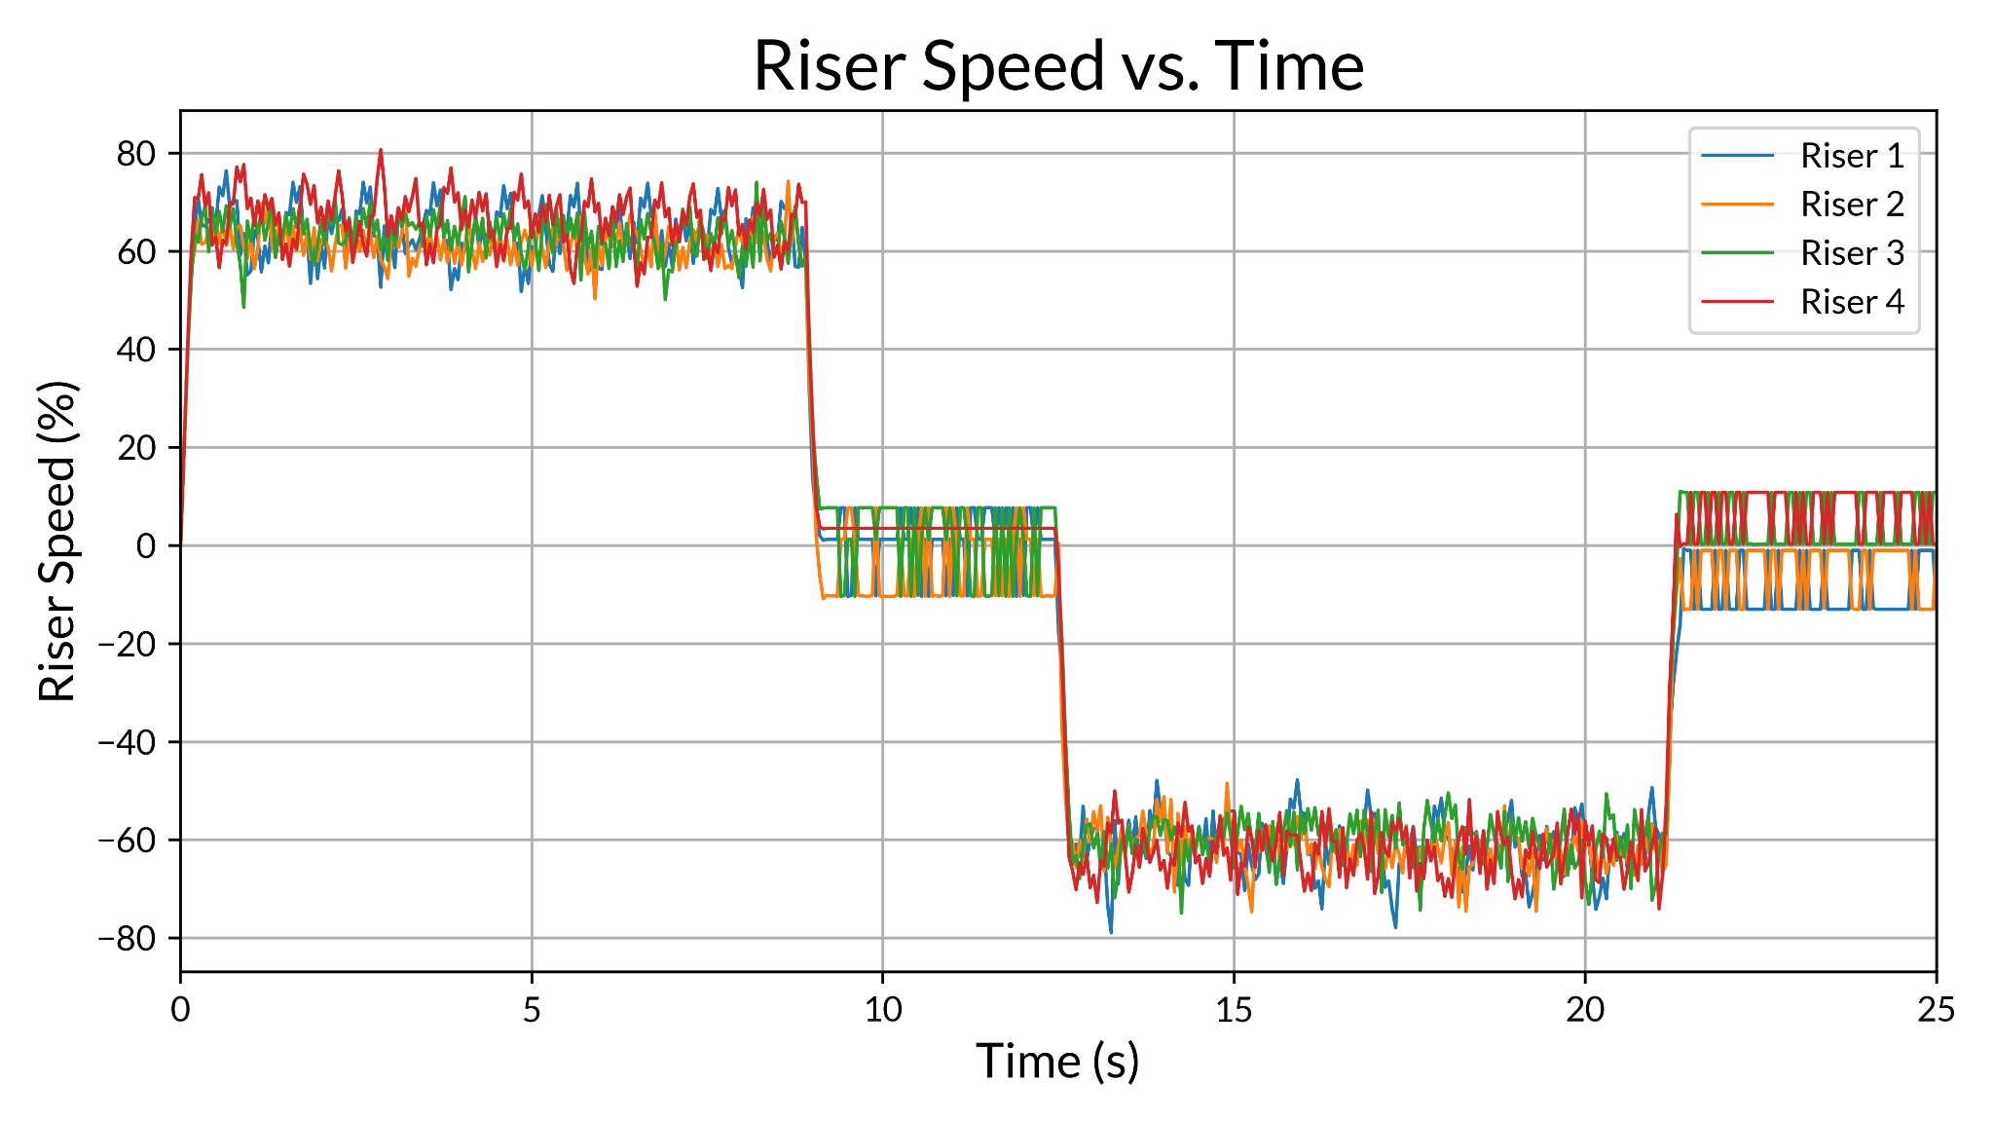

**Figure A.2.** Riser speeds in percentage of maximum speed throughout test trajectory

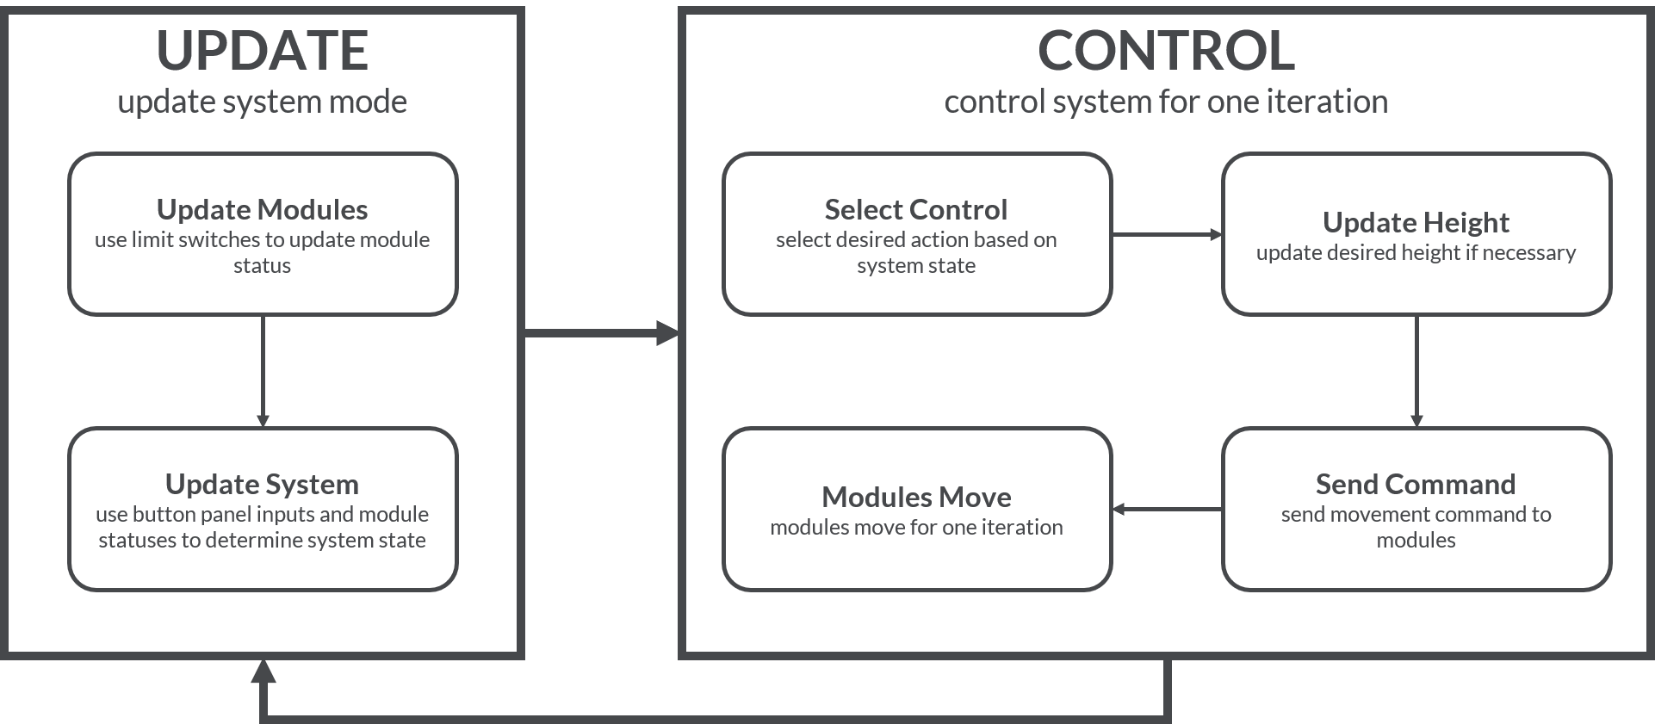

**Figure A.3.** High-level software control scheme

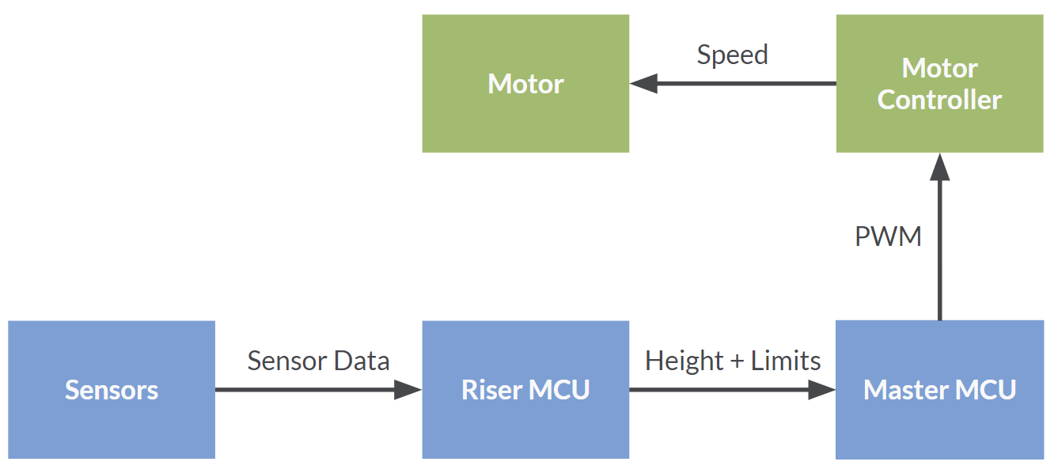

**Figure A.4.** High-level overview of data flow between electronics

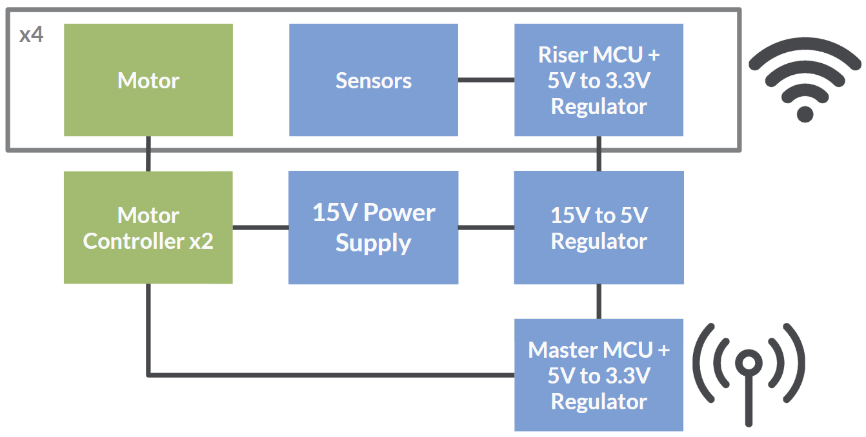

**Figure A.5.** Simplified electrical architecture and communication

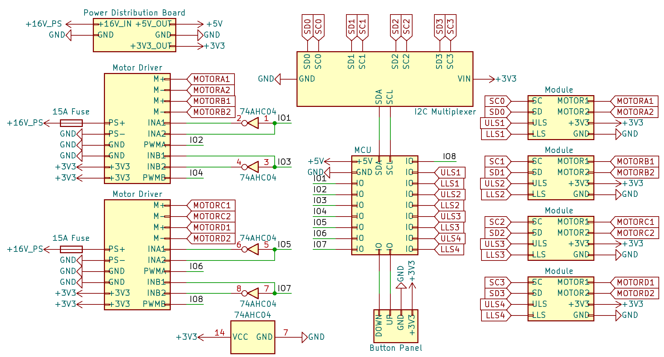

**Figure A.6.** Original full electrical architecture diagram using I2C wired communication

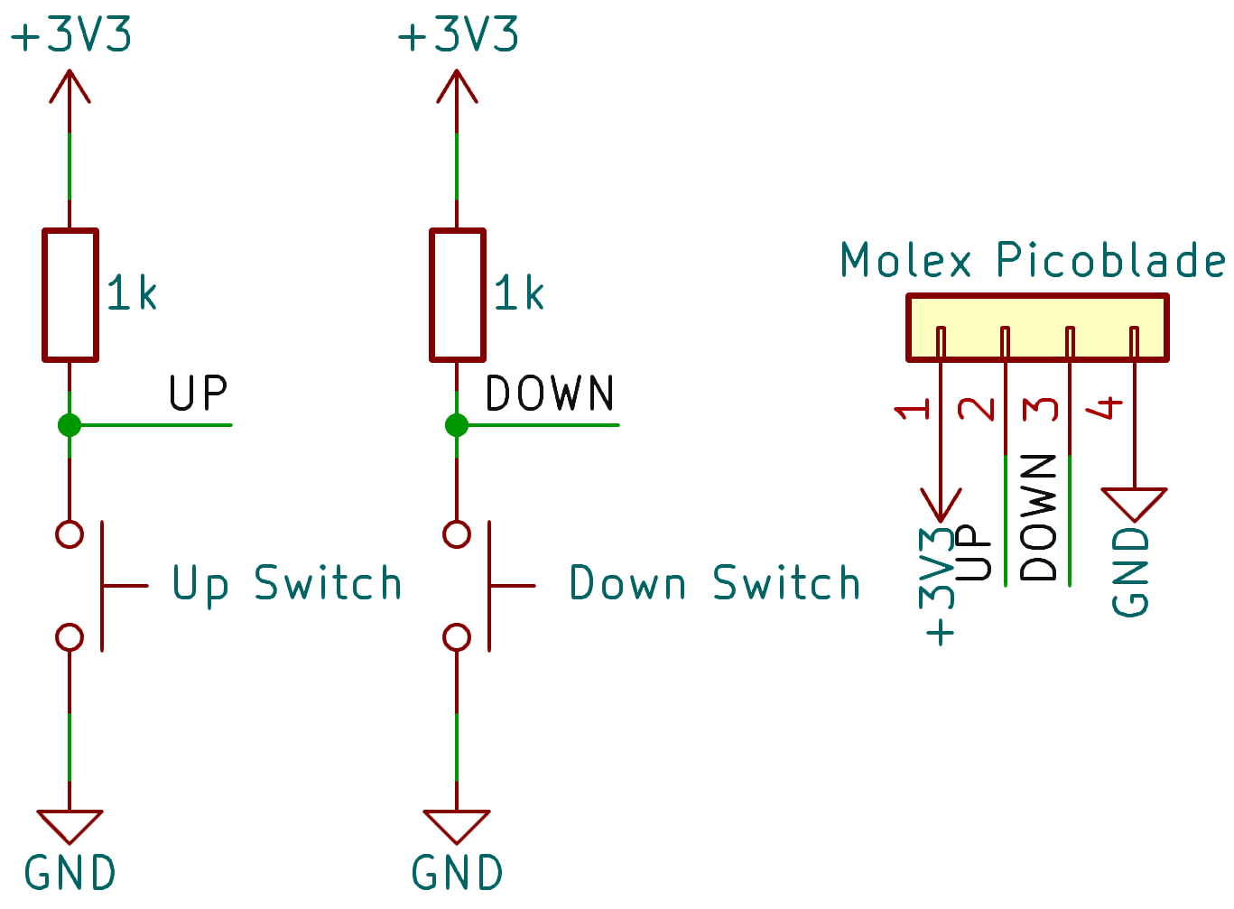

**Figure A.7.** Circuit diagram for button panel

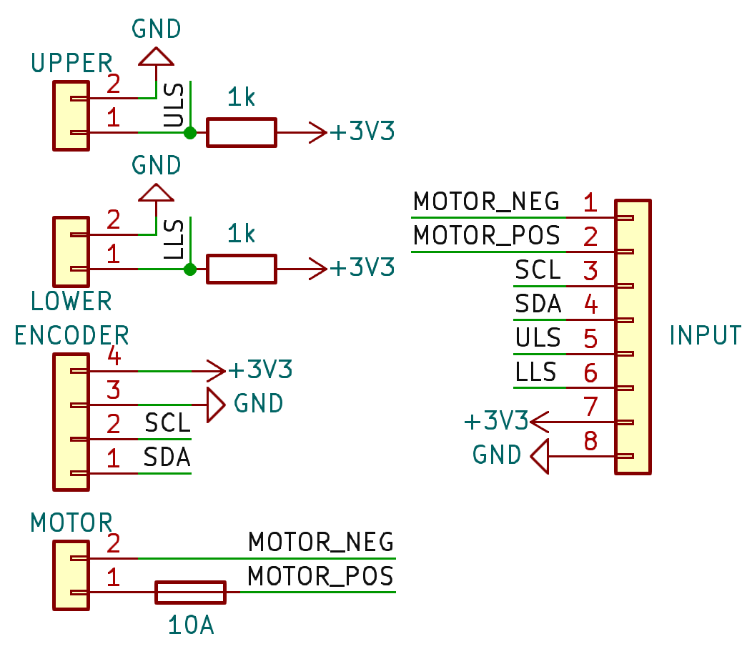

**Figure A.8.** Circuit diagram for splitter board using I2C wired communication

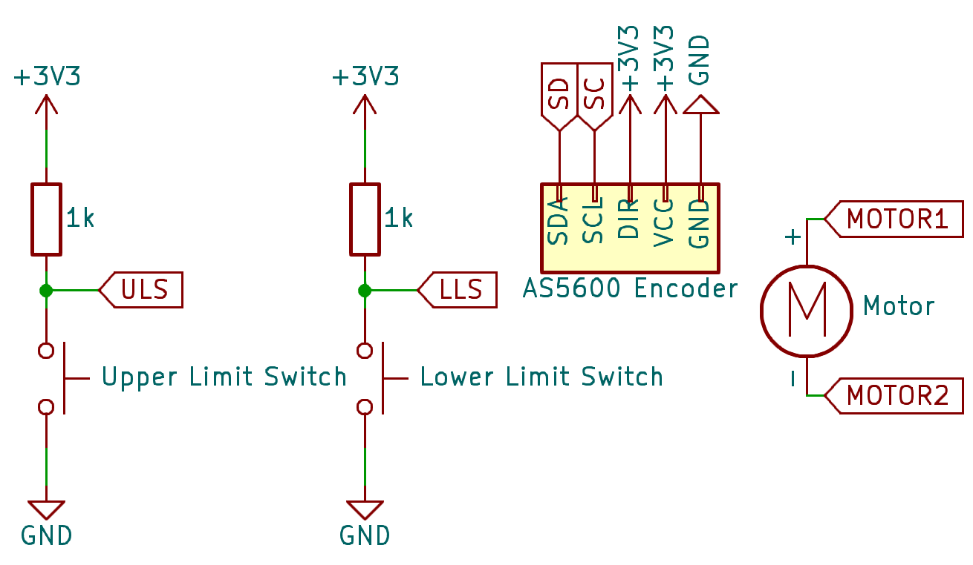

**Figure A.9.** Schematic for riser electronics using I2C wired communication

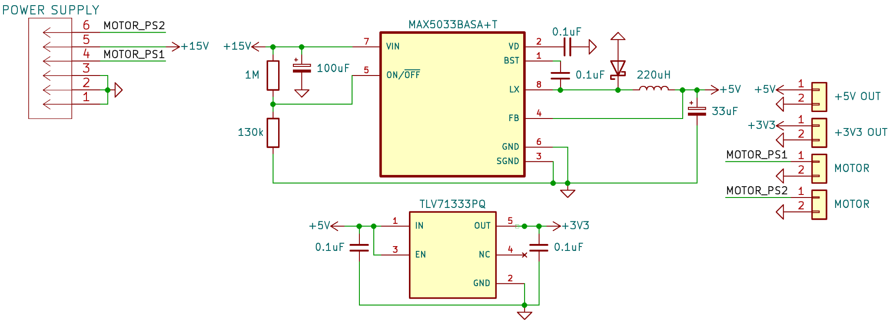

**Figure A.10.** Original power distribution board circuit diagram

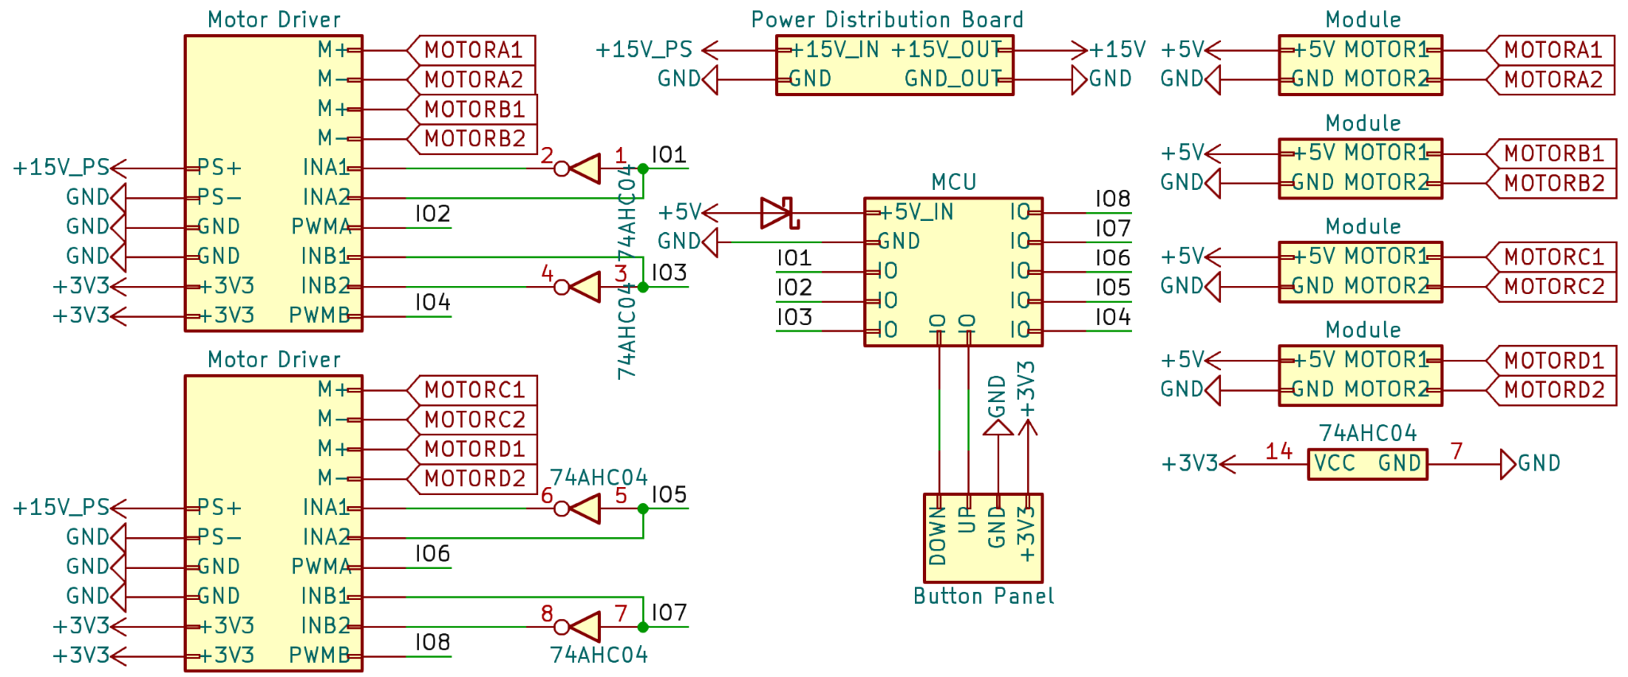

**Figure A.11.** Full electrical architecture diagram for final prototype

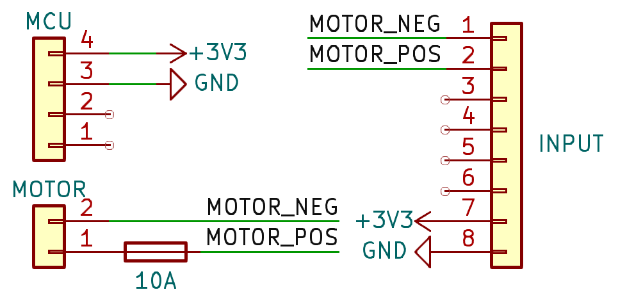

**Figure A.12.** Circuit diagram for splitter board for final prototype

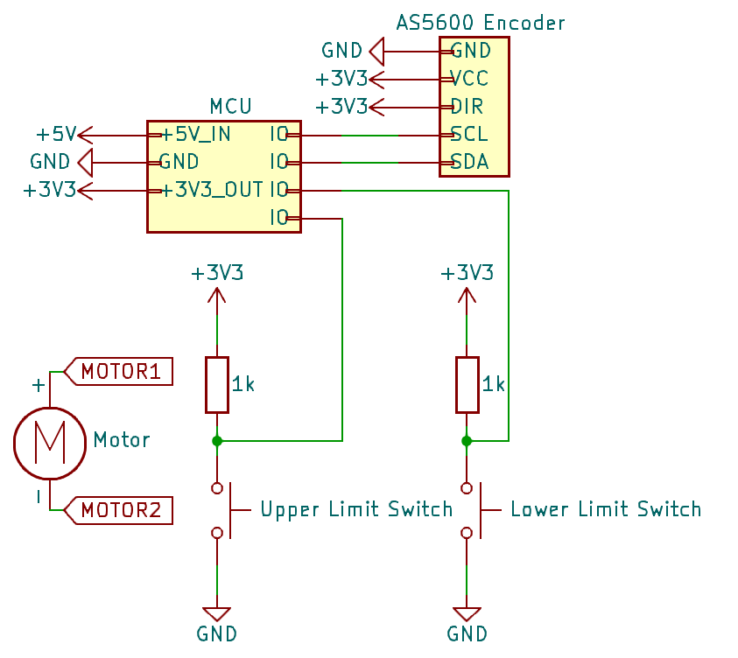

**Figure A.13.** Schematic for riser electronics for final prototype

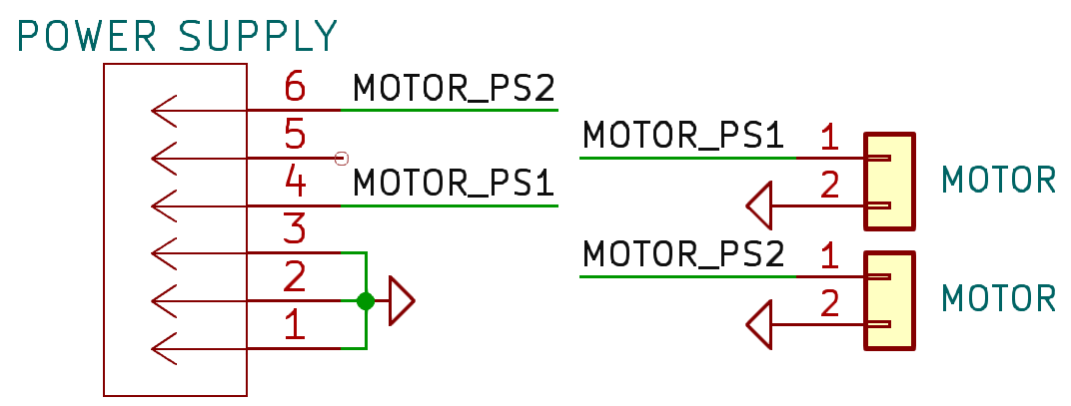

**Figure A.14.** Power distribution board circuit diagram for final prototype

# 

**Figure A.15.** Render of ELEVATE final product

**Table A.16.** Cost analysis breakdown of a $650 full-sized standing desk

| Item | Units | Dimensions | Purpose | Total Cost |
| --- | --- | --- | --- | --- |
| Bamboo Wood Sheet | 1 | 36" x 24", 6 square feet | Table Top | $99.99 |
| 30W Electric Motor | 2 | N/A | Lifting Mechanism | $48.12 |
| 12V Power Supply | 1 | N/A | Power | $12.99 |
| Square Steel Tube | 4' | 2.5", 0.083" Thick | Outer Telescoping Leg | $71.24 |
| Square Steel Tube | 4' | 2", 0.065" Thick | Inner Telescoping Leg | $22.52 |
| Steel Sheet | 2' x 2' | 0.135" Thick | Bracket Pieces | $47.20 |
| Square Steel Tube | 6' | 0.75", 0.083" Thick | Frame | $15.58 |
| Motor Controller | 1 | N/A | Lifting Mechanism | $20.79 |
| Microcontroller | 1 | N/A | Control Panel | $9.95 |
| Tactile Switch | 6 | N/A | Control Panel | $3.48 |
| Steel Sheet | 2' x 2' | 0.135" Thick | Feet | $47.20 |
| Stainless Steel Lead Screw | 4' | 1/2" Diameter | Lifting Mechanism | $71.16 |
| Worm Gear | 2 | N/A | Lifting Mechanism | $29.76 |
| Metal Housing | 2 | N/A | Lifting Mechanism | $30 |
| Plastics & Miscellaneous | 1 | N/A | Miscellaneous | $40 |
| **Total** |  |  |  | $569.98 |
| **Profit Margin** |  |  |  | $80.02 |

**Table A.17.** Solution selection matrix

|  | **Lead Screw** | **Hydraulics** | **Pneumatics** | **Rack and Pinion** | **Scissor Lift** | **Cascade Lift** |
| --- | --- | --- | --- | --- | --- | --- |
| **Cost** | ✅ | ❌ | ❌ | ✅ | ❌ | ✅ |
| **Reliability** | ✅ | ❌ | ❌ | ❌ | ✅ | ❌ |
| **Complexity** | ✅ | ❌ | ❌ | ✅ | ❌ | ❌ |
| **Resolution** | ✅ | ❌ | ❌ | ✅ | ✅ | ✅ |
| **Packaging** | ✅ | ❌ | ❌ | ❌ | ❌ | ✅ |
| **Safety** | ✅ | ❌ | ❌ | ❌ | ✅ | ❌ |

**Table A.18.** Survey of desk heights

